Hello, Portentum is here. This is a small document that describes the main differences between the ToT style and the TNO style. It is highly recommended to read the file before creating portraits, icons and super events.  
**PORTRAITS**

ToT portraits are made in TNO style. The main difference is the special template. Since the template makes the portraits darker, it is recommended to make them slightly lighter. How to insert a portrait into a template correctly?

Step one: insert the portrait under Layer 4.

Step two: make a copy of the portrait and add gauss.

Step three: don’t forget to return the clipping mask for Layer 4 and Layer 3, which is removed due to copying of the portrait

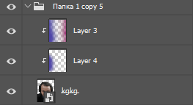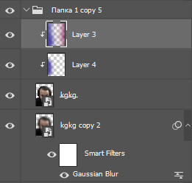

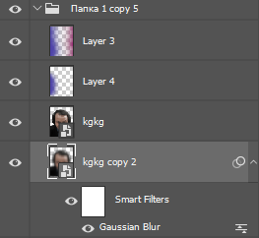

**ICONS**

Icons are also created in the TNO style. The main differences are slightly different effect settings (which can be obtained from the psd in the icons folder):

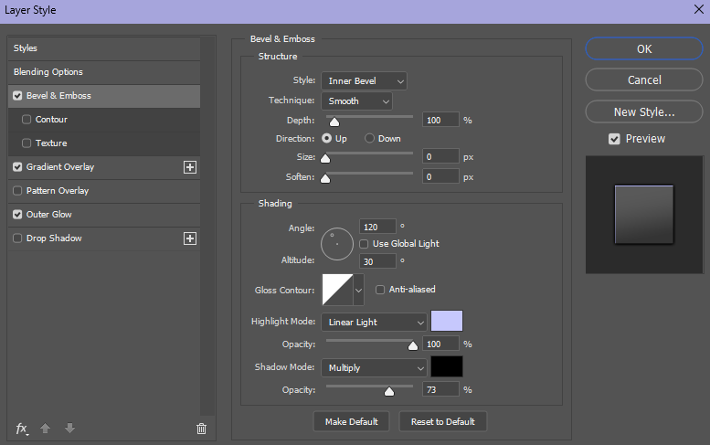

and special Lighting Effects settings. To be able to use them, you need to go to the psd of icons that are located in the Icons folder (you can also use frames from these files) and double-click on Lighting Effects in the list of effects and press Enter after opening a special window. After this, the special Lighting Effects settings will be saved.

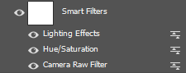

It is also recommended to lower the asset saturation by 60-80 units and use Photoshop 2021.

**SUPEREVENTS**

The order of ideologies can be seen in the template diagram. For fractions, you need to first use dark colors, then lighter ones. To edit the superevent itself, you need to double-click on the image indicated in red in the image below.



The same applies to the inscription of the name of the super event. After editing, you need to close the file and save the changes.

Fonts: Fifaks 1.0 dev1 for everything except the newspaper and superevent names and Balkara Condensed for the newspaper and superevent names.